Corvette tail lights in my ’77 280Z

I don't think the 280Z tail lights are all that attractive. In the never ending quest to have a different look than everyone else I decided to use Corvette tail lights. Ok, I know I'm not the first person to use Corvette tail light in a Z but I like them. There was a company that actually made a panel for the Corvette light but alas they are no longer in business. So I will have to fabricate my own.

Again there are two choices, make it out of sheet metal or fiberglass. Once again the inability to weld makes that choice simple. I picked up four '85 Corvette tail lights off EBay and a 60x12 sheet of 1/8" fiberglass for $28 from McMaster-Carr and started building. I want four lights, which requires the stock back-up lights to be moved. I will relocate back-up lights to the valance once I get the exhaust and the new bumper mounted. I cut out enough area in the rear panel to accommodate the new lights and added a new brace between each pair to make up for the sheet metal I cut out. I’m not really sure that was necessary but I did not want the weight of the hatch distorting the top horizontal support. I fortunately noticed the hatch latch mounting bolts need to be accessed from the outside of the car. I had to make an access port in the new tail light panel in case I ever have to service the hatch latch. I modified the stock rear sheet metal panel by removing the bump-out and the cap-screw tabs where the old license plate bracket sat so the new panel would sit flat against the body. I had to do some body work to clean up the now exposed body sections that the original Datsun light panels covered like where the rear panel meets the fender sheet metal.

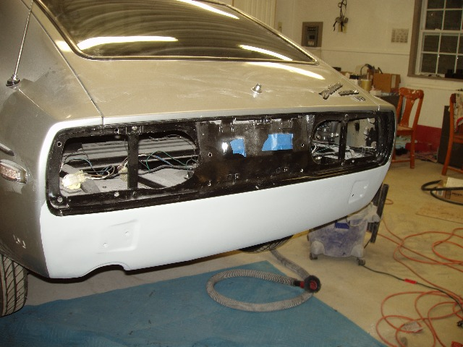

I carefully made a template out of cardboard for the panel; you know measure 15 times and cut once! Cut and test, cut and test until I had everything the way I wanted it. I then transferred the template to the fiberglass panel and cut it out roughly with a saber saw. Then I slowly trimmed it until I was satisfied with the fit. Lining up the light holes took some time too. There are no really straight lines to deal with here so positioning the lights uniformly wasn’t easy.

I did not want any exposed mounting hardware so the panel will bolt to the body from inside the truck utilizing hidden brass inserts in the panel. For the light panel to be solidly mounted to the rear body panel I added some strips of 1/8” fiberglass along the back edges and installed the brass inserts. The lights are 2” apart and recessed 1” with the slightly recessed license plate between the two sets of lights. To make the light recesses I made 4 fiberglass rings 5 5/8” in diameter, ¼” thick and 1” high and glassed them at each light cutout on the back of the panel. The lights sit on the back of these rings and are held in place with straps which are glassed onto the rings. I then sealed it with urethane on both the front and back to help prevent that exhaust fume smell these Z cars are noted for. I also cut out the area in the new panel for the license plate and recessed it about 1/2 “at the top and added inserts to bolt on the plate. The license plate is lighted by two LED strips mounted to the body above the tail light panel. All this is painted with the same trim black I used on the dash and spoiler and clear coated.
.
