Modify a ’77 280Z dash to accommodate a ’94 TransAM gauge cluster

Obviously the first question is why would you want to do this? I can only quote Jesse James when a cop asked him why he built a particular custom ride. “If you have to ask you’ll never understand”.

My 280Z has been drastically modified. The stock engine and transmission have been replaced with a ’94 Z28 5.7 liter V8 and a 4L60E automatic. The front bumper is fiberglass and the rear bumper is off a 72 240Z. The grille is out of a Dodge truck, the fog lights are from a Pontiac Gran Am and the fuel tank is from a Camaro. All the running lights have been changed to LED including the 85 Corvette tail light bulbs. The front brakes are Toyota and the rears were updated to 280zx discs. The interior has a custom console and the seats are Miatas. So as you can see this is what we call a HybridZ. Attempting to take what the owner thinks are better parts and adapting them to their ride.

Don’t get me wrong, there is nothing wrong with stock 280Z gauges in a stock 280Z. The look is classic and they function very well......most of the time. But newer cars use electronic gauges so the stock Z stuff does not play well with onboard computers. There are options that will allow you to have the gauges look like stock and will fit into the stock location but I chose to go a different route. Since I was replacing the entire wiring harness in my Z with the harness from a ’94 Z28 Camaro anyway using the Z28 gauges seemed a logical choice. Then I discovered the TransAM cluster not only fits better it looks better and the wiring was the same as the Camaro. The only issue was Chevy and Pontiac use different connectors to hook up the exact same wires, only GM knows why. Oh well there are only 32 wires to swap!!!

Getting the dash out of a 280Z isn’t that hard. There are only 4,586.672 bolts, clips and screws to remove the wiring harness, gauges, AC/heater controls and plumbing, radio and a few other things. Then you remove another 3 or 4 hundred screws and bolts that hold the dash in place. Once you have all those removed the dash come out and you need to remove the rest of the 100 or so screws that hold the pad on. What you are left with is a rather nicely built sheet metal dash.

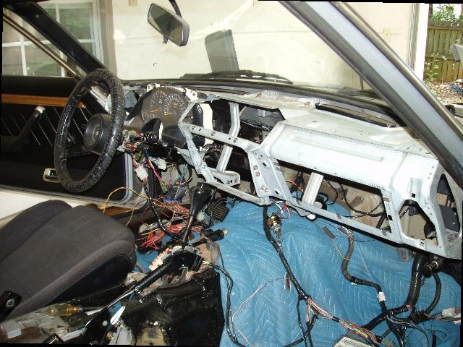

The fist thing I tackled had nothing to do with the gauges; it was the fuse panel on the Z28 wiring harness. It has to be mounted somewhere and the logical place is the end of the dash. After all that’s where most new cars put it so why reinvent the wheel. The Z dash isn’t quit wide enough to accommodate the Z28 fuse panel. I made a steel plate that the fuse panel would bolt to, temporarily bolted it to the end of the dash (this well be welded later) and cut out the section of the Z dash in the center of the new plate.

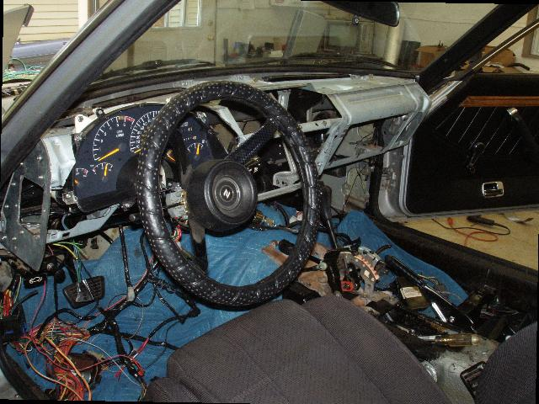

Of course you can not simply bolt a TransAm gauge cluster into a Datsun dash; it takes some modification, a lot of modification. One thing to always keep in mind on something like this is serviceability; you have to be able to easily remove the gauges after the dash in back in the car. I pretty much cut out all the Z dash in the area of the speedometer and tachometer almost all the way to the windshield on top and just above the steering column support on the bottom. The only “support” piece that was removed was a section between those two instruments. I then added brackets that will have captured mounting nuts for the new gauge cluster. These mounting brackets will be accessible without removing too much of the new dash so the cluster can be removed for service.

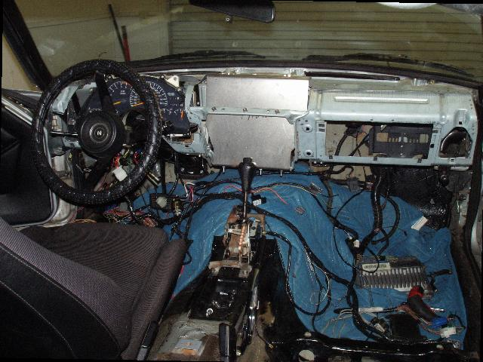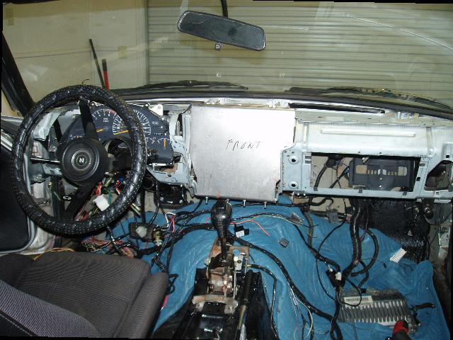

So much for the easy stuff, now I have to make this thing presentable. After all you can not drive around with a bare sheet metal dash now can you? The whole center section where the AC/heater controls, radio and other miscellaneous controls will reside needed to be modified as well since I am changing all of those. My plan was to fabricate using sheet metal as much as possible with limited sheet metal equipment and skills, cover it all with fiberglass, sculpting it into a smooth flowing piece of art, LOL. Oh I dream big!!!!

First project was the center section where all my new controls will reside. The very top has two AC vents which will be my main outputs for the Vintage AC unit. I picked up a ’85 Mustang AC vent for this. The rest of the center section will be the following:

AC Vents
Top slot:
Stereo unit
Middle slot:
Headlight and Fog Light Switch +12v Accessory port
Bottom slot:
Push Button Start Ignition Key Switch, Fuel Pressure Gauge
Between Center Panel and Console:
AC/Heater Controls

I first constructed a sheet metal piece that is flat where the slots are and then bends over the top of the Z dash. It is bolt it in place on top of the dash and on the stock Datsun bracket at the bottom (this will also be welded later). The Mustang AC vent will snap onto this. After this all lined up I marked and cut holes for all the controls, praying I did not mess this up, LOL.

I then needed to cover the TransAm cluster. Again using sheet metal I bent a section to become the top of the dash and temporarily bolted it in (more welding). I made a similar section for the front left side of the dash and on both sides of the center section. That finishes the sheet metal work.
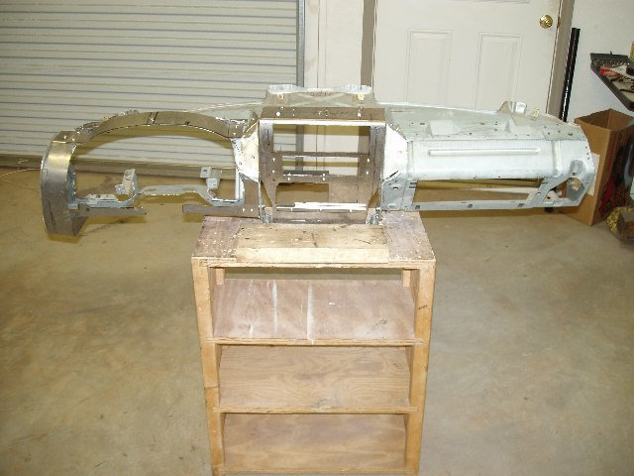

I had to make a removable bezel to surround the gauge cluster. I first made a mold from metal and then used fiberglass to make the inner part and a lip that would overlap the dash itself. This would need to be removable to allow access tot the gauge cluster for maintenance. It is attached with two screws along the bottom and one inside the bezel attaching it to the top of the dash. I trimmed it in rubber to prevent squeaking.

With this all accomplished it fiberglass time...YUK! Anyone that has done any work with fiberglass knows is not really all that much fun. Its messy, it stinks and is not as easy as it looks. The nice thing about it is that it is very adjustable. All you need is some sanding devices, some eye and lung protection and a lot of time and patience.

At long last the hard part is done. The dash body is finally completed; I have built the gauge cluster bezel and got it ready for paint. I decided to paint the bezel and the center panel with a metallic black paint and to texture the rest of the dash. For the textured look I used a SEM plastic prep followed by 3 coats of SEM textured black paint, 3 coats of SEM black trim paint and added 3 clear coats over it all.

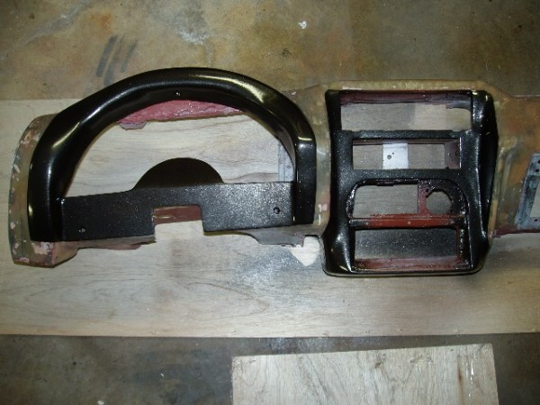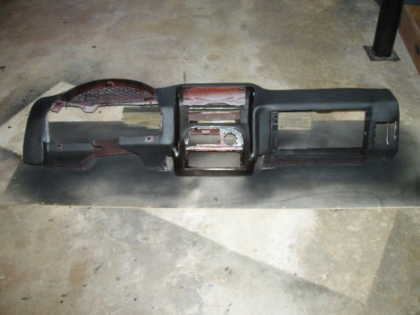

As the old hot rod expression goes....”double your budget and triple you time”. This took a long time but I am pretty pleases with the result. I will probably catch hell for the Z purists. Oh well, who cares, it is my car and my creation.

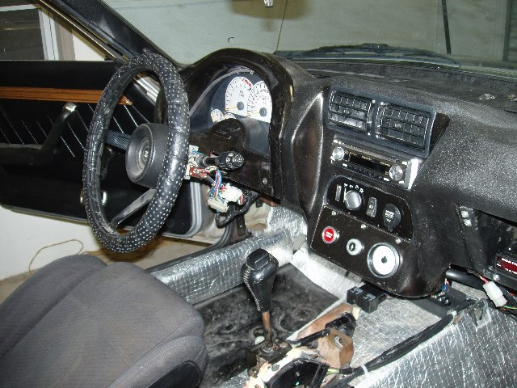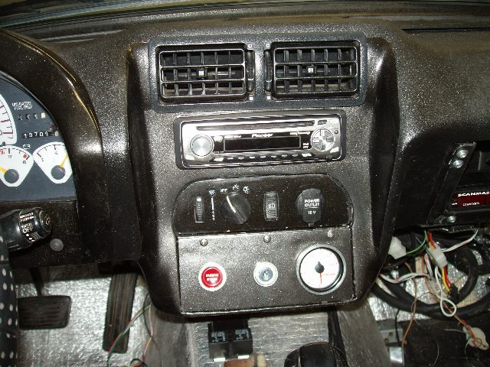

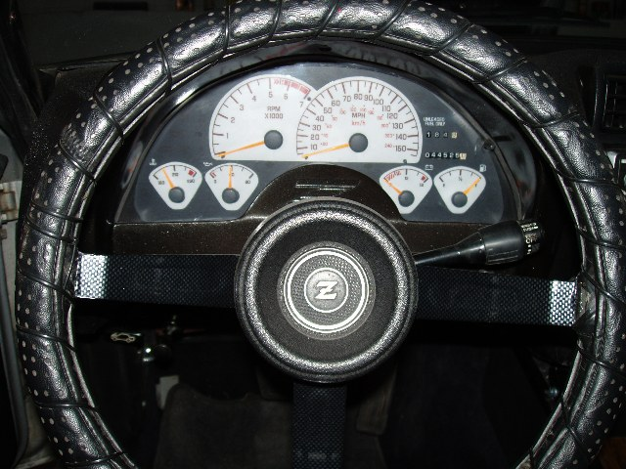

Now how about that console..............................................................................

